Good afternoon TJMS Families,

I hope you are all safe and well.  As we approach the end of  2020-2021 and prepare for the 2021-2022 school year , please note the following:

**1.  APS Student/Family Selection Process Opens for the 2021-22 School Year**

Arlington Public Schools is offering families two choices for the 2021-22 school year: full in-person learning, five days per week; or a K-12 full distance learning program, five days per week.

In preparation, **all families must complete the selection process, now available in ParentVUE, by Fri., April 30, 2021 at 11:59 PM for each student enrolled in APS**. **Once the window closes, your selection cannot be changed until the end of the first semester for middle and high school students.** All families are asked to choose an instructional model and provide information regarding Transportation and Extended Day services. (Note: Extended Day registration will happen later this spring.) This information is vital for planning, staffing and preparing schedules for the new school year.

Information about both models, [in-person learning and the K-12 full distance learning program](https://www.apsva.us/school-year-2021-22/), is available on our website, as well as in the **“Resources & Links”** **tab in ParentVUE**. Answers to [Frequently Asked Questions](https://www.apsva.us/school-year-2021-22/faq/) are also provided on the APS website to assist families in making their choice.

APS will continue to implement the recommended mitigation measures to provide the safest possible in-school experience, based on evolving guidance from U.S. Centers for Disease Control and Prevention (CDC) and Virginia Department of Health (VDH).

1. Log in to ParentVUE with your username and password.
2. As soon as you log in, you will be in the “Student Info” tab.
3. On the top of the “Student Info” page, click “Edit Information.”
4. Scroll to the middle of the “Student Info” edit page to select your choices for the instructional model and transportation questions.
5. After selecting your choices, scroll to the top or the bottom of the page and click “Save Changes.”
6. If you have multiple students, you will need to complete this process for each student, by selecting their name in the box located in the upper-left corner of the screen in ParentVUE.

**To access ParentVUE and complete the process, visit:** [**https://vue.apsva.us**](https://vue.apsva.us/).

For additional information or assistance with accessing ParentVUE, contact the TJMS main office at 703-228-5900.

**2.  3rd Quarter Report Cards are now available in ParentVue**

For additional information or assistance with accessing ParentVUE, contact the TJMS main office at 703-228-5900.

**3.  TJMS SOL Testing**

**All SOL testing will be done in-person at TJMS in May and June,** with safety protocols in place.  Yellow Jackets who change from virtual to in-person instruction after April 19th, 2021, will test with virtual students on Monday testing dates.  Parents who do not wish for their student to participate in state and/or federally mandated assessments due to COVID-19 concerns, should contact the below staff by email to discuss scheduling options or request information on opting out.

SOL testing is a TJMS community effort.  Your Yellow Jacket will perform at his or her best if he/she has a good night’s rest, a healthy breakfast, and arrives to school on time. You may help with test preparations by not scheduling appointments during the testing period.

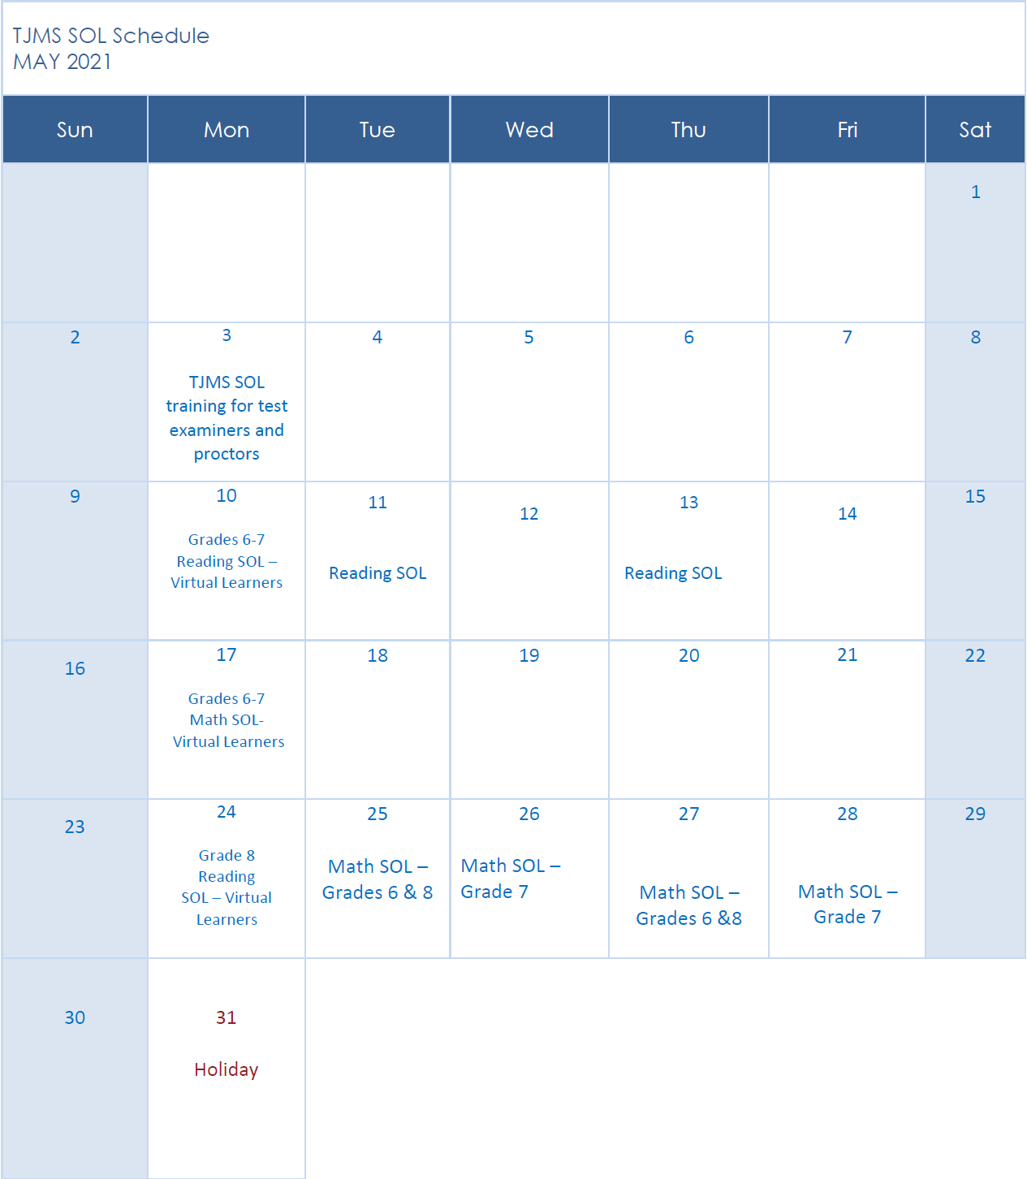

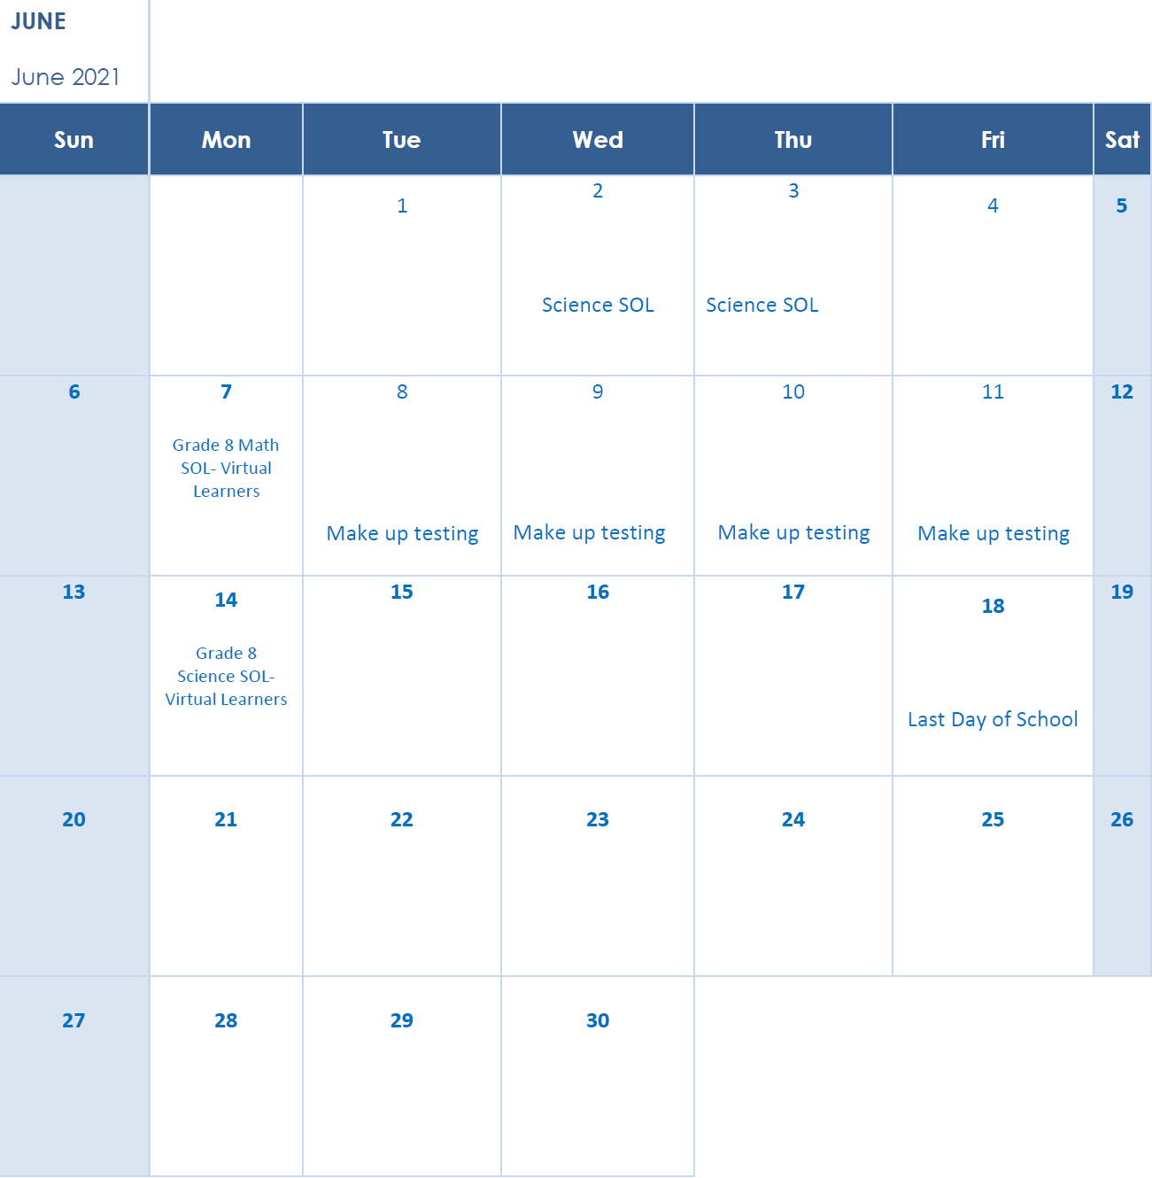

Stay Safe,

K. Boggan