Instructions:
User must enroll the device. First power on the device. At Welcome screen select United States (you may need to scroll down) and click Continue. Select US keyboard layout and click Continue. | 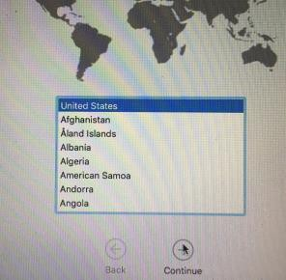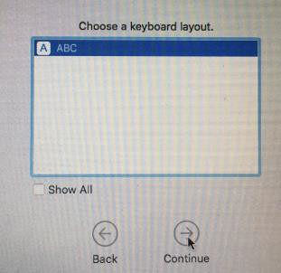
Select APS wireless network. Enter your APS login account (first.lastname) and password.  Click Continue on Authenticating to  network “APS”  Click Continue on Remote Management screen. Note: If you do not see the Remote Management screen STOP and RETURN device to APS staff for help.  Enter APS account login and password then click sign-in  Select Your WI-Fi Network Click Continue.  Click Continue on Data & Privacy screen | 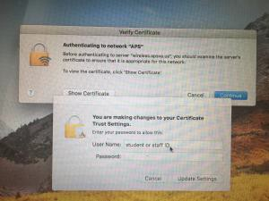  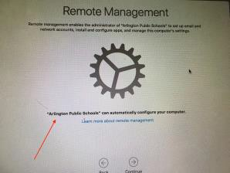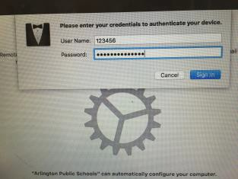
At the create a Computer Account screen: Enter your full name in the Full Name field. (Login ID and password should already be populated.) Click continue.  Click continue again on Express Setup  Click Continue at the Authenticating to network “APS”. Enter login/password and click Update Settings.  Click Allow on VMware AirWatch Agent, then click Ok to allow AirWatch to determine your computer’s location.  Close System Preferences window after it opens. | 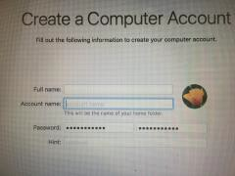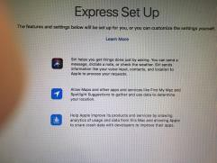  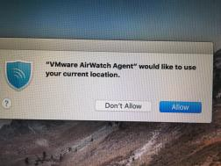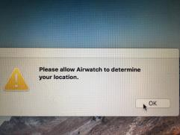

APS wallpaper (blue) and the App Catalog need to install.  Locate the icon for Air Watch agent in the menu bar at the upper right. If it is blinking, it is installing something. You can also click on it and select Sync Now if you are waiting for something.  You may need to restart once or twice to see the blue wallpaper and App Catalog. | 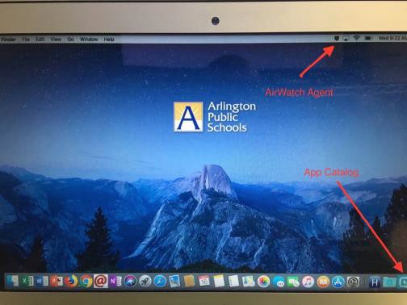
Locate the App Catalog on the bottom right side of the Dock.

If App Catalog not showing, restart the computer and check again. Contact your ITC if you do not get App Catalog after 1 or 2 restarts.
Close Security and Privacy window when it pops up.
Installing Apps:  Go to the App Catalog to install apps. Select the app needed. Allow AirWatch Agent to stop blinking. Open the LaunchPad to locate the installed app or check on installation progress. | 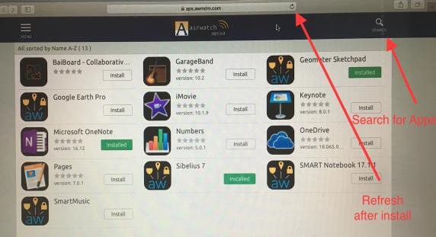  App Catalog

Activate Microsoft Office 2016
  - Open Word from the dock,
  - Click Get Started, then Sign in and enter your APS credentials (use full email for Office 365
prompts)
  - If you have difficulty (can’t edit) check under the Word/Powerpoint/Excel menu to see if it says “Activate” or “Sign out.” If it says “Activate,” you haven’t successfully set it up.

You should set up One Drive or Google File Stream to safely store all of your files. Files saved to other locations on your laptop will be lost if your hard drive fails or your laptop is reimaged

- Installing Apps on your Laptop (Available from APS or home)
  - Go to the App Catalog
  - Find the App you want to install and click install
  - Wait for the Agent in the menu to stop blinking, then open the LaunchPad to locate the installed app.
  - You will need to install Smart Notebook, etc. as needed.
  - Teachers are admin users on their laptops. You can install other apps but be careful to follow copyright laws. If an app interferes with other APS apps your laptop will need to be reimaged.

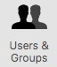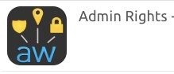Make Sure you are an admin user
  - Go to and select System Preferences - Users & Groups
  - If your account says Standard, Go the App Catalog and install “Admin Rights - are yourself an admin”.
  - You will need to restart your computer after the install.

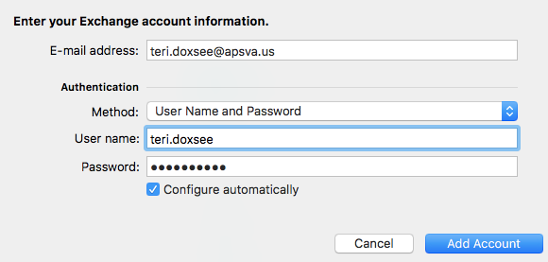
Set up Email
- Outlook
  - Open Outlook from the Dock
  - Select Add Account
  - Select Exchange or Office 365
  - Enter your email address, user name and password

Install Network Printers (You must be on APS wifi)
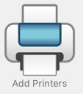
You must be an admin user in order to install a printer (see #5 above).
  - To install a printer at school, from the Dock and select Add Printers
  - You will be asked to sign in to APS
  - A Finder window will open with a list of APS Schools. Find your school name and open.
  - Double click the name of the printer you want to install.
  - Accepting the install
    - Click Open if you see this message
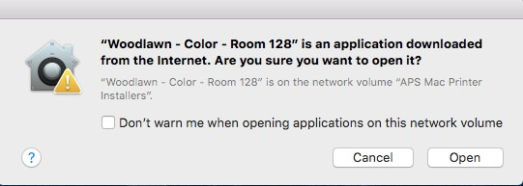

  - Note: Go to System Preferences under the apple logo and select Print & Scan to see the printers already installed. You should see the name of the printer you just installed in the list.

