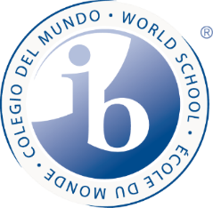
ELD English Language Arts
Syllabus 2019-2020
Teacher: Iris Jones
Email: iris.jones@apsva.us
Room: 245

Welcome to ELD English Language Arts. It is a pleasure to have you in my class. I hope that this will be a challenging, worthwhile experience that helps you grow as a learner, reader and writer, and advances your reading skill and knowledge of English.

Course Objectives
The objective of this course is to improve your proficiency in reading, writing, listening and speaking English, to prepare you for success in your future academic work. We incorporate Virginia English Standards of Learning (SOLs) for grades 6-8. We also incorporate the state WIDA English language proficiency standards, and we have specific language development objectives for students learning English.

In this course you will learn to:

Study literary works, communicate information, ideas and concepts necessary for academic success in the content area of Reading and English Language Arts. And you will:

Read (SOL 6.4-6.6, 7.4-7.6, 8.4-8.6)
- Expand your vocabulary knowledge
- Read a variety of fiction and non-fiction

Write (SOL 6.7-6.8, 7.7-7.8, 8.7-8.8)
- Develop narrative, expository and persuasive writing
- Develop your writer’s voice
- Use new vocabulary and grammar in writing; edit writing
Research (SOL 6.9, 7.9, 8.9)
- Use reference materials to create a research product
- Use reliable websites to locate factual information

Develop Oral Language (SOL 6.1-6.3, 7.1-7.3, 8.1-8.3)
- Use new vocabulary and grammar structures when speaking
- Make oral presentations
- Produce, analyze and evaluate media messages
- Share ideas with partners and small groups
- Develop skills in listening for key information

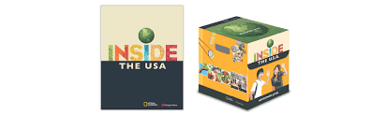
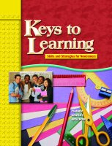
Main Texts

For reading & writing:
- Keys to Learning
- Inside the USA
- Lexile leveled novels
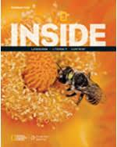
For grammar & writing:
- Inside (National Geographic Learning)

Course sequence for the school year:
Topic | Timeline | SOL | How Assessed
- The English Alphabet  - Word Recognition  - Days and Months  - Decoding Practices  - Study/Application Skills | September-  October | SOL 6.4-6.7, 6.9, 7.4-7.6 | Verbal/Writing assessment  Role Play  Notebook assessment  Sentence writing  Recollection
- Family  - School Lessons  - Numbers/Colors  - Theme | November-December | SOL 6.1-6.3,6.7,-6.9,  7.7-7.8 | Notebook assessment  Word recognition assessment  Sentence writing  Paragraph development
- Community  - Food  - Clothes  - Character | January-February | SOL 6.1-6.3, 6.7, 7.1-7.3 | Writing assessment  Oral assessment  Notebook assessment  Paragraph writing
- Weather  - Family  - Home Life  - Cause and Effect | March-April | SOL 6.1-6.3, 6.9, 7.1-7.3, 7.7-7.8 | Writing assessment  Discussion Circles  Portfolio assessment  Annotated note taking
- Emotions  - Calendar and time  - Biography Study  - Conflict | May-June | SOL 6.1-6.3, 6.9, 7.1-7.3, 7.7-7.8 | Learning Station assessment  Writing assessment  Portfolio assessment  Biography Choice assessment
* Bolded topics will be taught across different lessons throughout the school year.

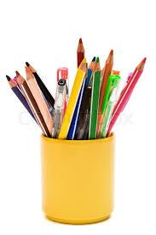
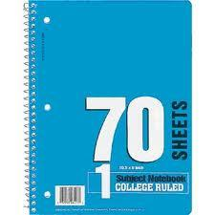
Materials Needed (daily)
- A spiral notebook for a writing journal
- Writing utensils
- A fully charged iPad

Grading
Grades are based on how well you meet the objectives for the assignment. The first table explains the grading scale. The second table explains how much each type of assignment will count towards your final grade.

GRADING SCALE
Letter Grade | Percentages | Quality Points
A | 90, 91, 92, 93, 94, 95, 96, 97, 98, 99, 100 | 4.0
B+ | 87, 88, 89 | 3.5
B | 80, 81, 82, 83, 84, 85, 86 | 3.0
C+ | 77, 78, 79 | 2.5
C | 70, 71, 72, 73, 74, 75, 76 | 2.0
D+ | 67, 68, 69 | 1.5
D | 60, 61, 62, 63, 64, 65, 66 | 1.0
E | 0 – 59 | 0.0

Grade Calculation
Assessments | 25%
Coursework | 25%
Projects | 30%
Homework | 20%

Criteria /Objectives | Maximum Score
Criterion A: Comprehending spoken and visual texts | 8
Criterion B: Comprehending written and visual texts | 8
Criterion C: Communicating in response to spoken and/or written, visual texts | 8
Criterion D: Using language in spoken and/or written form | 8

* Late work policy: You must complete assignments and tests that you have missed within one week.

- Student grades reflect student achievement and not student behavior.

Final Grades
Students who meet the guidelines to move to the next language proficiency level (Level 2) receive a P for the Year Grade. If students do not meet the guidelines to move to the next proficiency level, they receive an S if their work over four quarters was satisfactory or a U if their work was unsatisfactory. They will repeat the same proficiency level but will move to the next grade.

Academic Honesty Policy
Students are expected to adhere to the TJMS Academic Honesty Policy. See the TJMS Student Handbook for more information.

Technology Expectation

Canvas
Students are expected to login to Canvas daily in order to access materials for class, announcements, homework, and other resources. Canvas is accessible through the iPad App or with the following link: https://apsva.instructure.com/

*For more specific assistance with Canvas, please see:
https://jefferson.apsva.us/technology-resources/digital-learning-initiative-updates/canvas-for-students/

Students should use their normal APS login for Canvas:
Student APS login: Student # (example: 102200@apsva.us)
Student APS password: Student date of birth or the password that students receive through TA classes.

All videos such as BrainPOP that are used for review are linked through this Canvas course. Additionally, links that students will need in order to see examples of what they are to do is linked through Canvas.

Absences
Check Canvas - you will find that it is very easy to keep up with all assigned work! You must complete assignments and tests that you have missed within one week of your absence.
Expectations

As your teacher, I am here to support you. I expect you to:

- Honor our classroom rule which is to respect our environment and each other.
- Actively participate in your learning and give your best effort! Why? Because you are the best!

Let’s have a great year!

